

Carbon PRO Report

Environmental Planting

Pages Creek, NSW

9th July 2025

## Overview

The following is a property-specific assessment of select variables that are important to consider when assessing the feasibility of developing an Environmental Planting (EP).

You will be able to view fundamental information regarding the potential opportunity and obstacles to project development.

With a PRO and PRO+ subscription you will also have access to more elaborate information and interpretation of additional factors that are required for critical review in the decision-making process of your land assessment and project development.

Table 1. Summary of project details

|  |  |
| --- | --- |
| Project Name: | Pages Creek |
| **Location:** | (Figure 1) |
| **Project Type:** | Environmental Plantingkeep-icon-material-symbols-outlined:psychiatry |
| **Project Area:** | 2,873 ha |
| **Planting Area:** | 1637.76 ha |
| **Climate Classification** | Temperate, no dry season (warm summer) |
| **Local Government Area (LGA)** | Upper Hunter |
| **NRM region** | Hunter Local Land Services |
| **IBRA region** | This project is located within the NSW North Coast Interim Biogeographic Regionalisation for Australia (IBRA) region. |

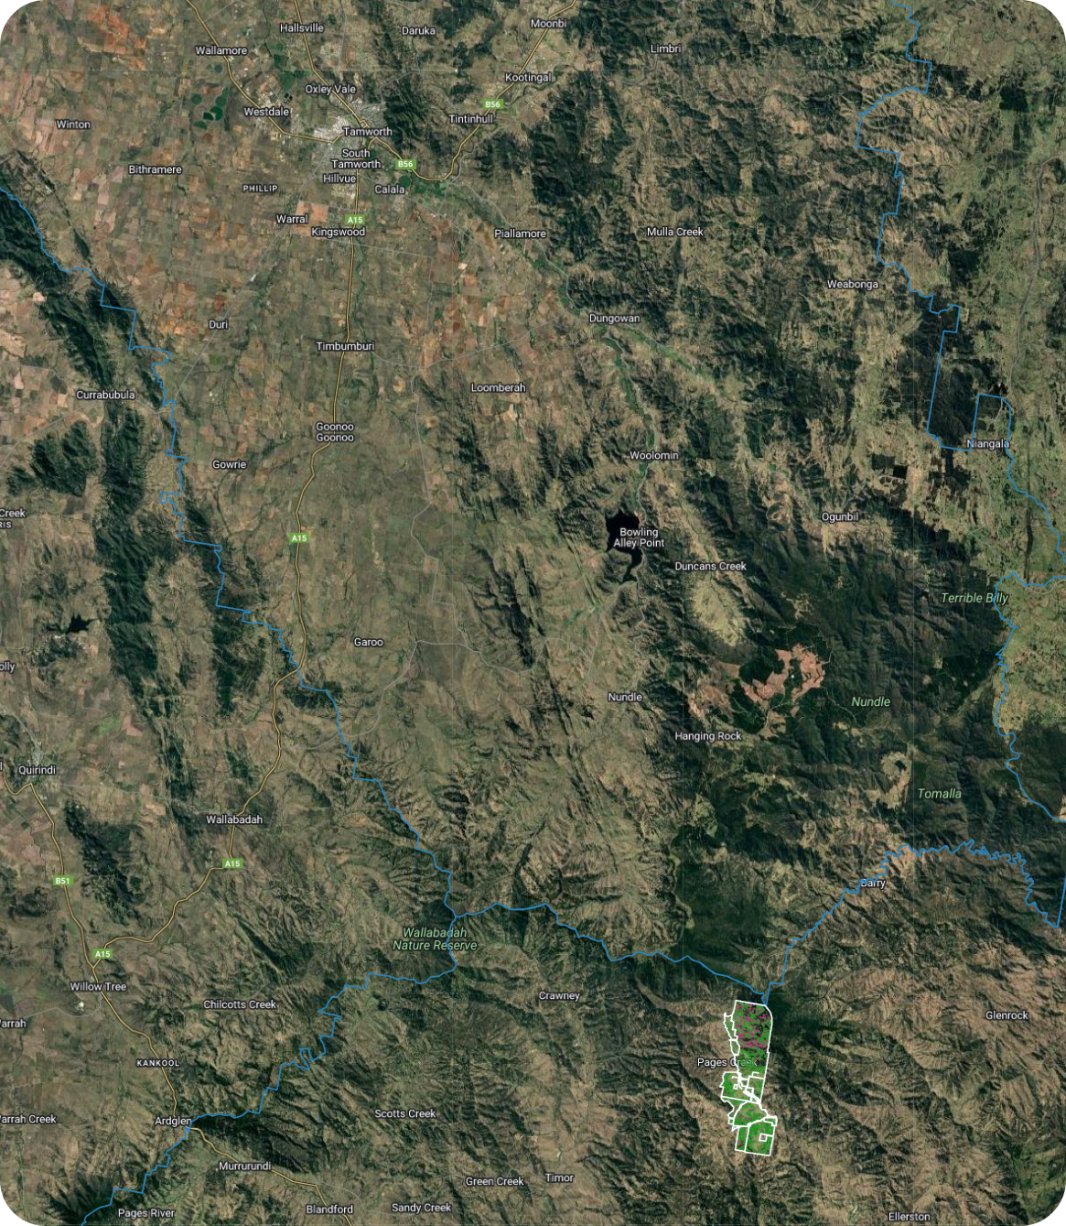

Figure 1. Location of the Pages Creek property in relation to surrounding localities. The property is identified by the white polygon.

### Summary of key risks affecting a carbon projects feasibility

*Table 2. Summary of risk assessment.*

|  |  |
| --- | --- |
| Item assessed | Assessment |
| Planting Area | **Very low risk.** Less than 5% of the planting area is classified as ineligible. |
| Carbon Returns | **High returns.** 26.3 ACCUs/ha/year. |
| Slope | **Very high risk.** The slope within the planting area is highly variable and often steep, which is expected to increase operational complexity and associated costs. |
| Other Land Uses | **Very high risk.** There is an existing registered CER project located in the property area. There are no mining tenements, exploration licenses or native title claims intersecting with the property or occurring in the immediate area surrounding the property. |
| Infrastructure | **Very low risk.** No major infrastructure intersects with the Pages Creek property. |
| Tenure | **Very low risk.** The entire property is Freehold. |
| Zoning | **Very low risk.** Property is entirely RU1 and RU4. |
| Climate | **Low risk.**  The property is situated in a region where days below zero are frequent in late autumn and early spring. |
| Drought Risk | **High risk.** The region is susceptible to increasing dry periods in recent years. |
| Fire Risk | **Moderate risk.** Property hosts a large amount of fire prone land and fire frequency in the region is common. |
| Flood Risk | **Very low risk.** The property is flat and adjacent to major waterways. |
| Salinity | **Very Low risk.** There are no areas mapped to be at risk of salinity within the property but the region has a high risk of dryland salinity. |
| Vegetation Classification | **Very low risk.** The majority of MVG and PEVs are able to achieve forest cover. |
| Soil | **Very low risk.** Dominant soil type across the property is suitable for revegetation. |

# Carbon

This section provides information that allows you to evaluate the carbon potential of your project area, assess eligibility with the Environmental Planting method and generate valuable insights for optimising project returns.

## Planting Area

The Clean Energy Regulator (CER) sets specific eligibility requirements for what qualifies as a planting area in environmental planting projects under the Emissions Reduction Fund (ERF). These requirements are intended to minimise the risk of perverse environmental outcomes driven solely by carbon credit generation, while ensuring projects deliver a net increase in carbon sequestration.

Using the National Forest and Sparse Woody dataset, a two-stage process is used to estimate the planting area:

1. Assessment and removal of areas where land clearing has occurred within the project area in the last 7 years[1].
2. Calculating the planting area as the total remaining area that is classified as ‘non-woody’ and that is not an identified exclusion area.

Represented on the map, approximately 1637.76 hectares of the total property area are classified as eligible for the establishment of an EP carbon project (Figure 2a, Table 3). An estimated 94.97 hectares (less than 5%) have been deforested over the past seven years (Table 3). The property presents a very low risk profile, with most of the proposed area deemed suitable for project development.

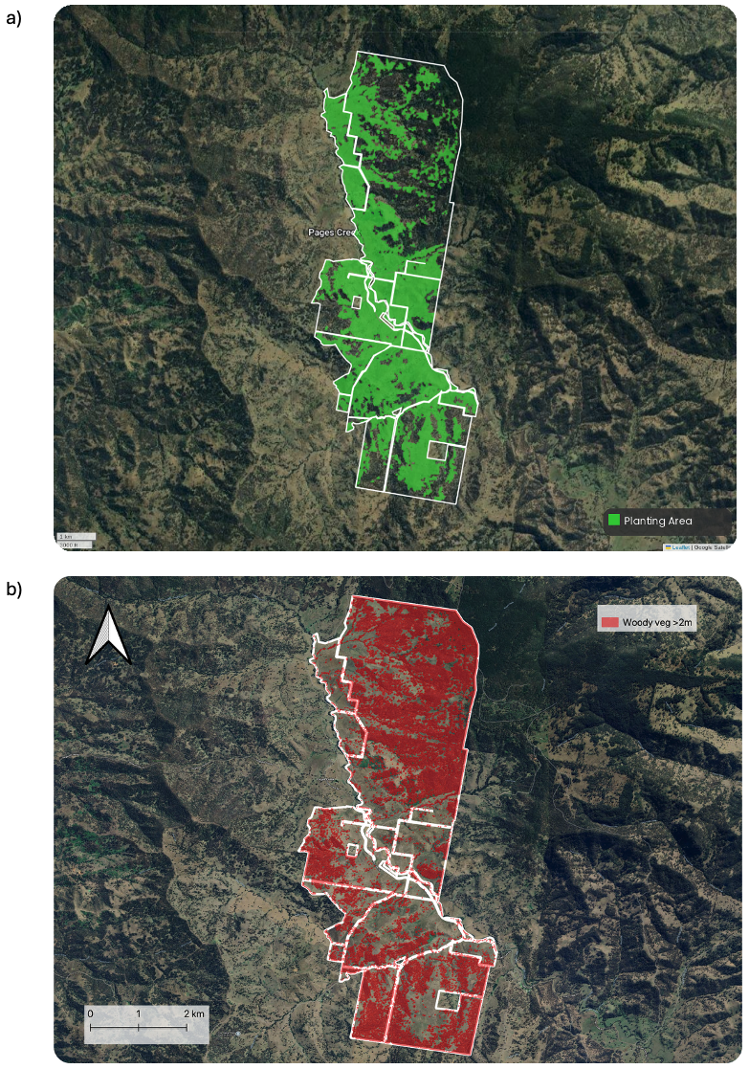

Figure 2. a) Planting / non-woody areas of Pages Creek property; b) exclusion areas of Pages Creek as defined by grovia’s tree detection model.

*Table 3. Detailed breakdown of estimation of exclusion areas and eligible planting area for Pages Creek as estimated by grovia and user input.*

|  |  |  |
| --- | --- | --- |
| **Category** | **Total Area (ha)** | **Percent Cover (%)** |
| Project Area | 2,873.30 | 100.00 |
| User Specified Exclusions | 0.00 | 0.00 |
| Recently Deforested* (ineligible) | 94.97 | 3.31 |
| Tree Cover (ineligible)** | 981.07 | 34.14 |
| Planting Area <0.2 ha (ineligible) | 12.50 | 0.44 |
| Roads | 13.17 | 0.46 |
| Unsuitable***   * Waterbodies * Other | 133.83 | 4.66 |
| Infrastructure | 0.00 | 0.00 |
| Total Eligible Planting Area | 1637.76 | 56.99 |
| * The National Forest and Sparse Woody Vegetation data indicates that woody vegetation loss has likely occurred in the past 7 years. These areas require further assessment before being included it in the project area. ** As defined by grovia’s tree detection model.  ***Planting in these areas may require additional consideration. | | |

## Carbon Assessment

Carbon assessment is critical in evaluating the potential of a carbon project, as it quantifies how much carbon can be sequestered or avoided over time. This directly informs the project's carbon yield—the amount of carbon dioxide equivalent (tCO₂e) captured per hectare annually. Understanding carbon yield helps determine the environmental impact and economic viability of the project, guiding decisions on land use, management practices, and long-term returns.

A carbon heatmap visually represents the distribution and capacity of the land to store aboveground carbon. This allows you to review and potentially optimise your planting area based on the estimated carbon yield. The highest yielding regions are located in the northern portion of the property, forming a west-to-east gradient with peak returns concentrated in the western segment. The remainder of the property exhibits relatively uniform yields, with the lowest values occurring in the central-west area (Figure 3).

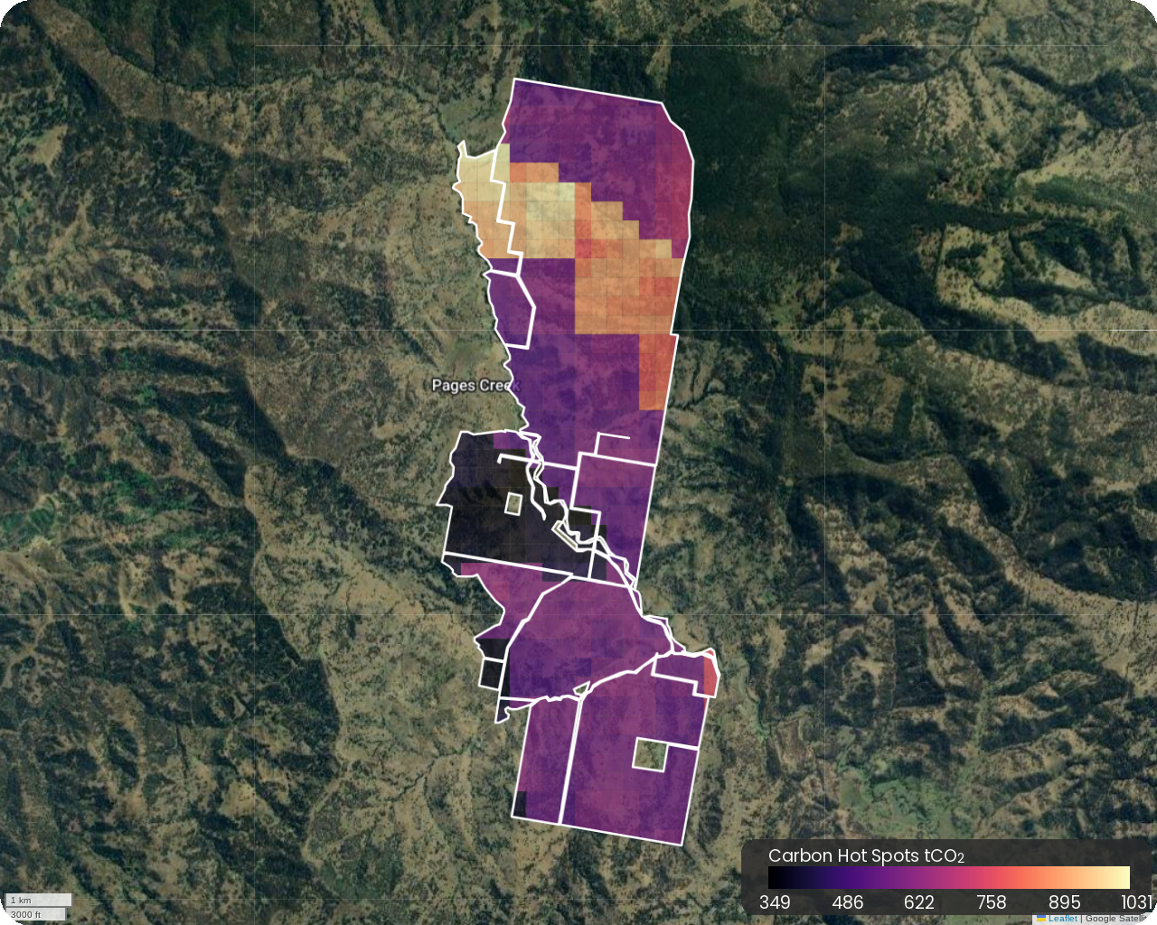

Figure 3. Spatial distribution of carbon yield across the property.

An initial method-compliant FullCAM carbon assessment stratified the property into 48 carbon estimation areas (CEAs) (Figure 4). CEAs were defined by land homogeneity indexed by pre-European vegetation classification. It is highly recommended that a site visit is conducted to assess other factors such as land management history may have influenced variations in site characteristics.

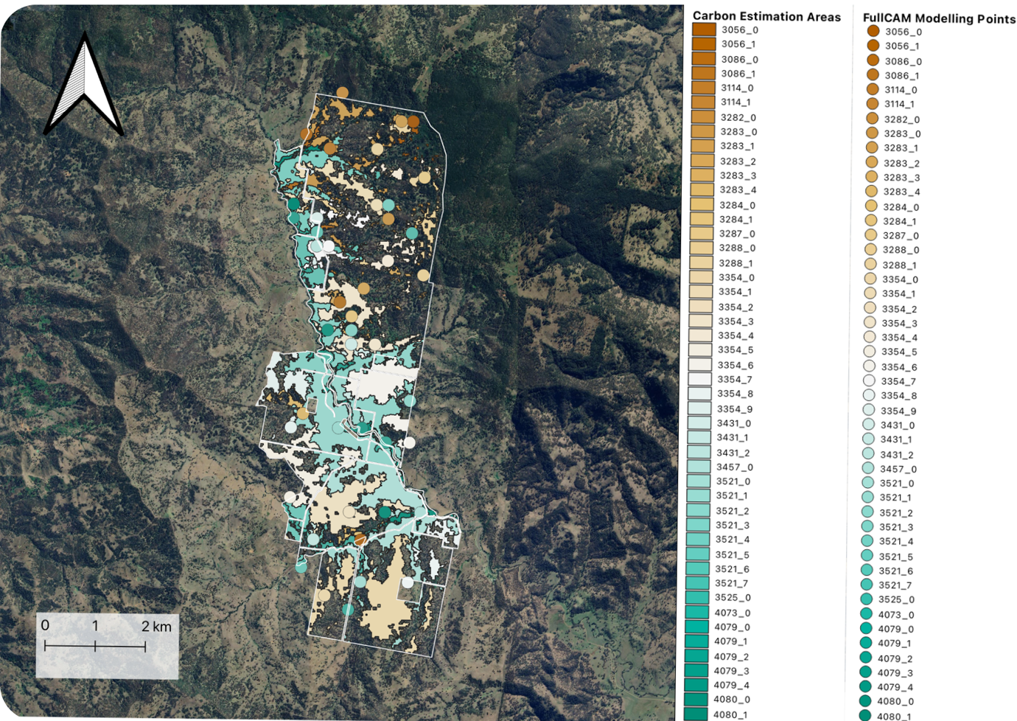

Figure 4. CEA stratification and modelling points of Pages Creek property.

The initial desktop FullCAM carbon assessment indicated a potential return of 26.3 tCO2/ha/year, equivalent to approximately 807,776 Australian Carbon Credit Units (ACCUs) when considering the risk of reversal buffer for a project registered with a permanence period of 25 years (Table 4). A breakdown of ACCU generation can be seen in Table 5 and Figure 5.

**Key Action**: A site visit is required to refine the planting area and determine other factors that may result in further CEA stratification before re-running a method compliant FullCAM assessment.

*Table 4. Detailed breakdown of estimated carbon yield from an initial FullCAM carbon assessment.*

|  |  |
| --- | --- |
| **Metric** | **Value** |
| Project Planting Area | 1637.76ha |
| Estimated Carbon Yield - Gross |  |
| * Project Total | 1,077,034 tCO2e |
| * per ha | 657.63 tCO2e |
| * per ha per year | 26.3 tCO2e |
| Estimated Carbon Yield - Net |  |
| * 25-year Permanence | 807,776 ACCUs |
| * 100-year Permanence | 1,023,183 ACCUs |

### Carbon Credits

This section provides insight into the total credit issuance trajectory of gross Australian Carbon Credit Units (ACCUs) over a 25-year permanence period.

*Table 5. The cumulative generation of gross ACCUs each year over the 25-year permanence period.*

|  |  |  |
| --- | --- | --- |
| **Year** | **Cumulative ACCUs  (25 year permanence period)** | **Annual ACCU issuance** |
| 1 | 15,707 | 15,707 |
| 2 | 54,524 | 38,817 |
| 3 | 112,567 | 58,043 |
| 4 | 180,205 | 67,638 |
| 5 | 251,014 | 70,809 |
| 6 | 321,316 | 70,302 |
| 7 | 389,291 | 67,975 |
| 8 | 453,610 | 64,319 |
| 9 | 514,062 | 60,452 |
| 10 | 570,592 | 56,530 |
| 11 | 623,418 | 52,826 |
| 12 | 672,455 | 49,037 |
| 13 | 718,067 | 45,612 |
| 14 | 760,469 | 42,402 |
| 15 | 800,062 | 39,593 |
| 16 | 836,817 | 36,755 |
| 17 | 871,089 | 34,272 |
| 18 | 903,077 | 31,988 |
| 19 | 933,032 | 29,955 |
| 20 | 960,988 | 27,956 |
| 21 | 987,178 | 26,190 |
| 22 | 1011,737 | 24,559 |
| 23 | 1,034,869 | 23,132 |
| 24 | 1,056,560 | 21,691 |
| 25 | 1,076,993 | 20,433 |

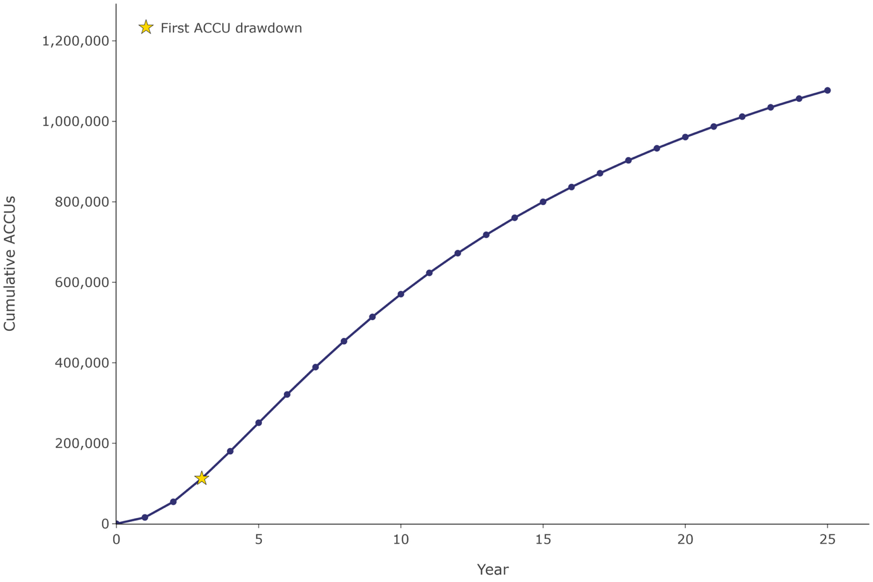

Figure 5. Accumulation curve of gross ACCUs generated each year over the 25-year permanence period. The first recommended reporting period of the permanence period is illustrated by a yellow star.

# Site information

To determine whether a project area is suitable for a carbon sequestration project (such as environmental plantings under the Emissions Reduction Fund (ERF)), several factors must be assessed, including topography, infrastructure and land titles.

## Slope

Slope is an important consideration for assessing EP carbon projects as it can directly influence future planting operations such as the operation of heavy machinery or by limiting accessibility. This section and the corresponding map overlay ‘Slope’ provide an overview of the topography of the specified project area.

The property features a varied and complex topography, ranging from flat valley floors to steeply inclined slopes (Figure 6). Approximately 28% of the total eligible planting area consists of flat to gently sloping land, where planting operations are generally manageable and pose minimal operational challenges (Table 6). However, if the entire property is considered for EP project development, the varied terrain presents substantial logistical difficulties. Steeper sections, in particular, pose a very high operational risk and are likely to increase both complexity and cost.

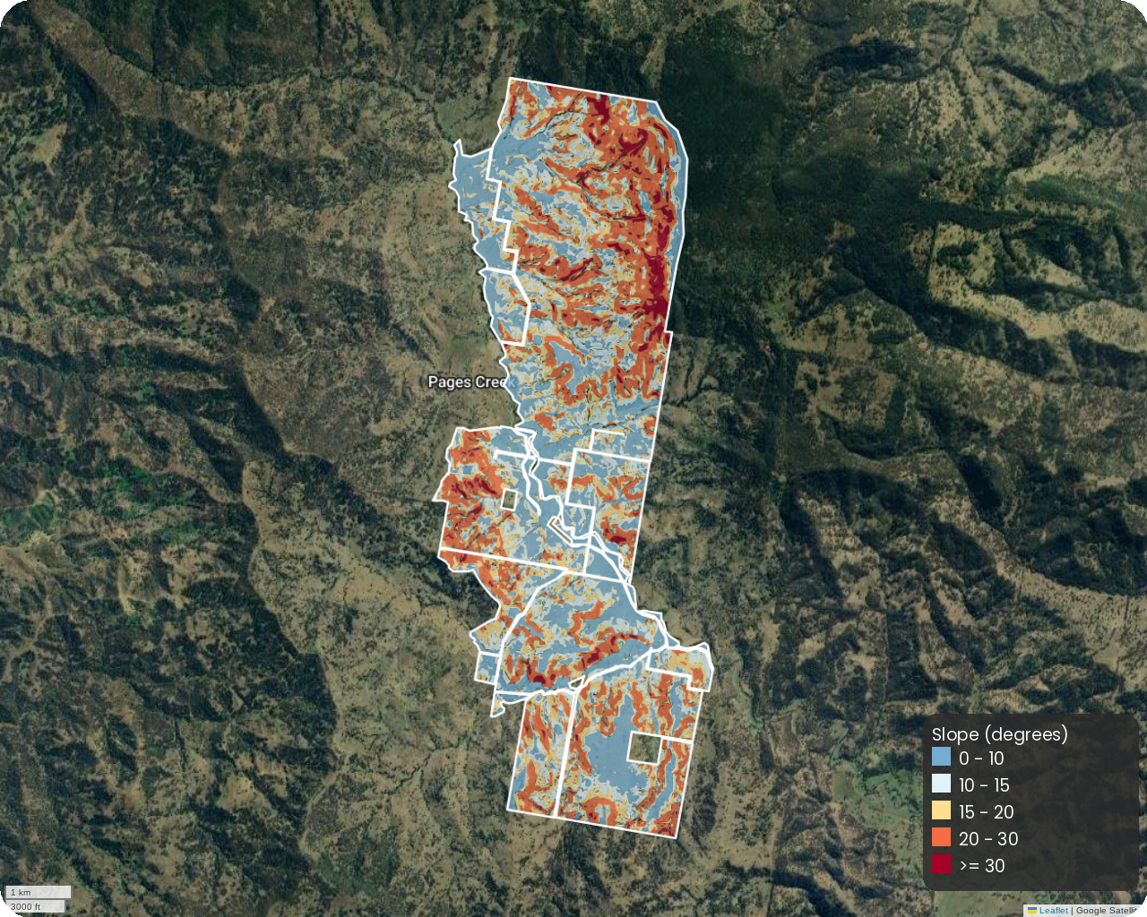

*Figure 6. Slope across the property.*

*Table 6. Planting area defined by slope.*

|  |  |  |
| --- | --- | --- |
| **Slope (degrees)** | **Planting Area (ha)** | **Planting Area (%)** |
| 0 - 10 | 804.53 | 28.00 |
| 10 - 15 | 648.56 | 22.57 |
| 15 - 20 | 606.88 | 21.12 |
| 20 - 30 | 709.75 | 24.70 |
| >= 30 | 103.28 | 3.60 |
| Total | 2873.01 | 100.00 |

## Infrastructure

Effective planning of carbon sequestration projects requires a thorough assessment of how existing infrastructure affects land suitability and project boundaries. Features such as buildings, sheds and water storage must be clearly identified to establish appropriate buffer zones and ensure that project development does not compromise the functionality or accessibility of these assets.

This also extends to major infrastructure such as transmission lines, as they can present several risks to a carbon sequestration project, particularly environmental planting projects under the Emissions Reduction Fund (ERF). These risks can affect project eligibility, carbon credit generation, and long-term permanence obligations. For example, if transmission line operators require land clearing for maintenance or upgrades, this could violate the permanence requirement, jeopardizing ACCUs already issued.

Property-specific infrastructure is located predominantly in the centre and southern extent of the property (Figure 7). No other major infrastructure occurs within or around the property. Pages Creek presents as a low risk for project development. It is recommended that a site visit is conducted to determine appropriate buffers around existing infrastructure.

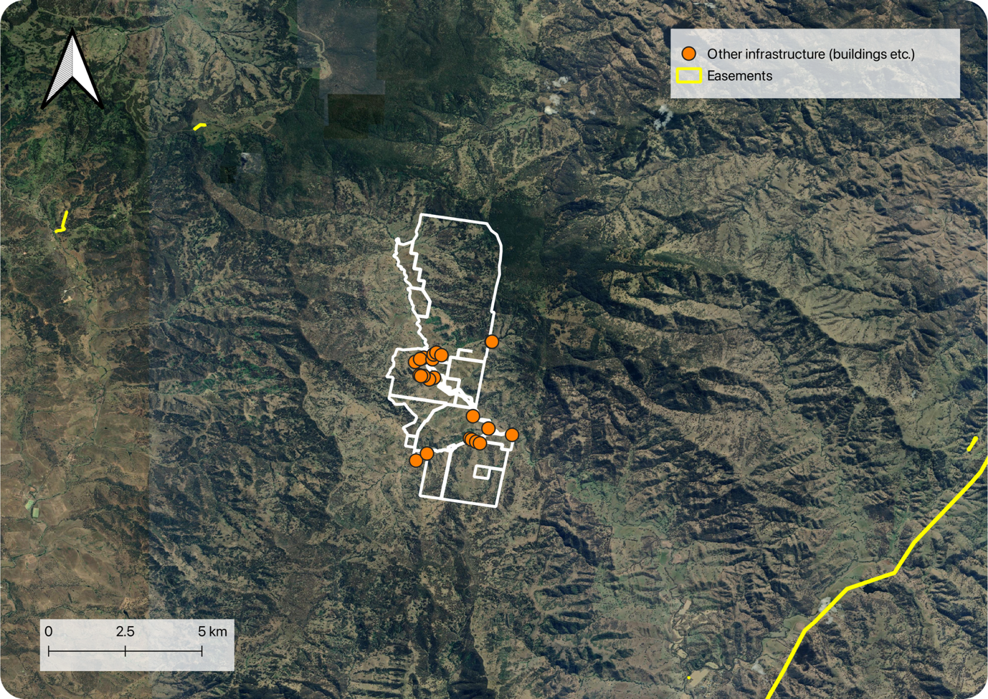

*Figure 7. Infrastructure that occurs within and around the Pages Creek property.*

## Tenure

Tenure is critical for carbon projects as it establishes legal ownership and land-use rights for the project site. Understanding the tenure type(s) of your project area is essential for determining project legitimacy, securing necessary permissions, and identifying key stakeholders involved in project development. Clear tenure ensures long-term stability and compliance, reducing risks to project success.

Initial assessment indicates that the property is entirely Freehold tenure with the presence of a single easement (Figure 8). Pages Creek presents as a very low risk for project implementation. It is recommended that a title check and legal expertise is required to confirm the tenure-type and the presence of easements that may not be digitally mapped.

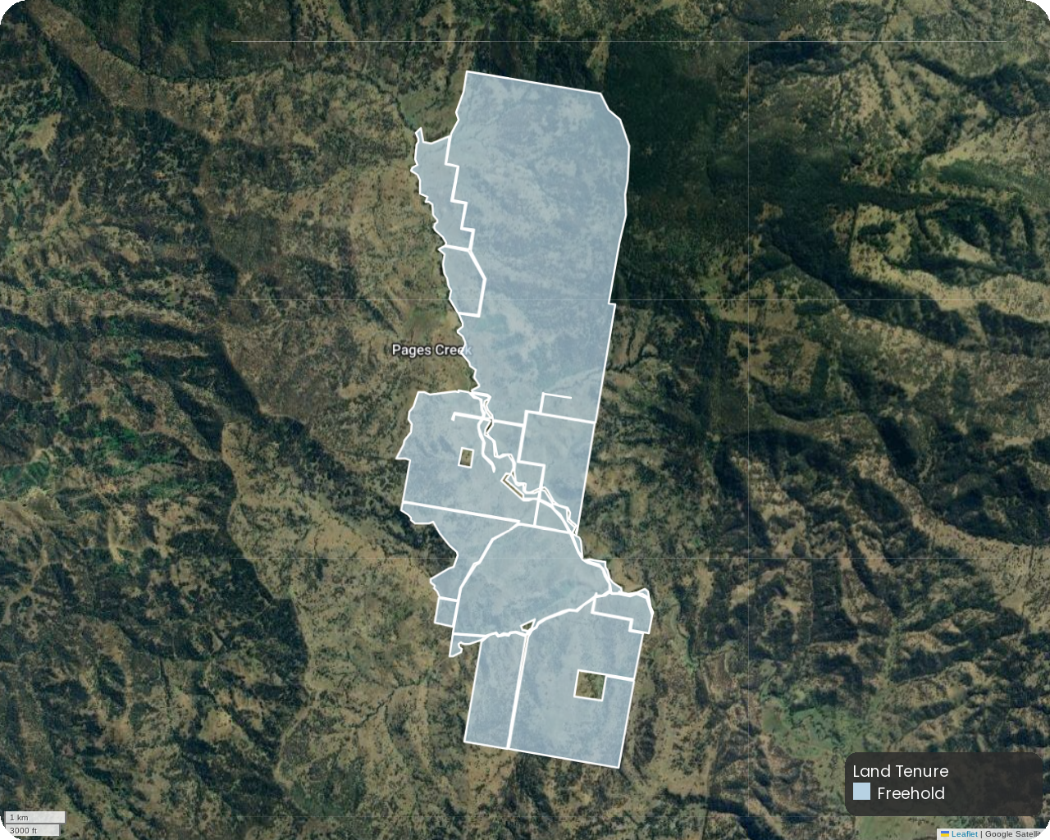

*Figure 8. State-based mapped tenure of the Pages Creek property.*

## Zoning

Zoning dictates how land can be used, ensuring that projects align with legal and regulatory frameworks. If zoning laws don’t support conservation or reforestation, a project might fail verification and not generate credits.

The Pages Creek property is zoned as Rural Zone (Division 1) and Primary production small lots (RU4) (Figure 9) and presents as a very low risk for project development.

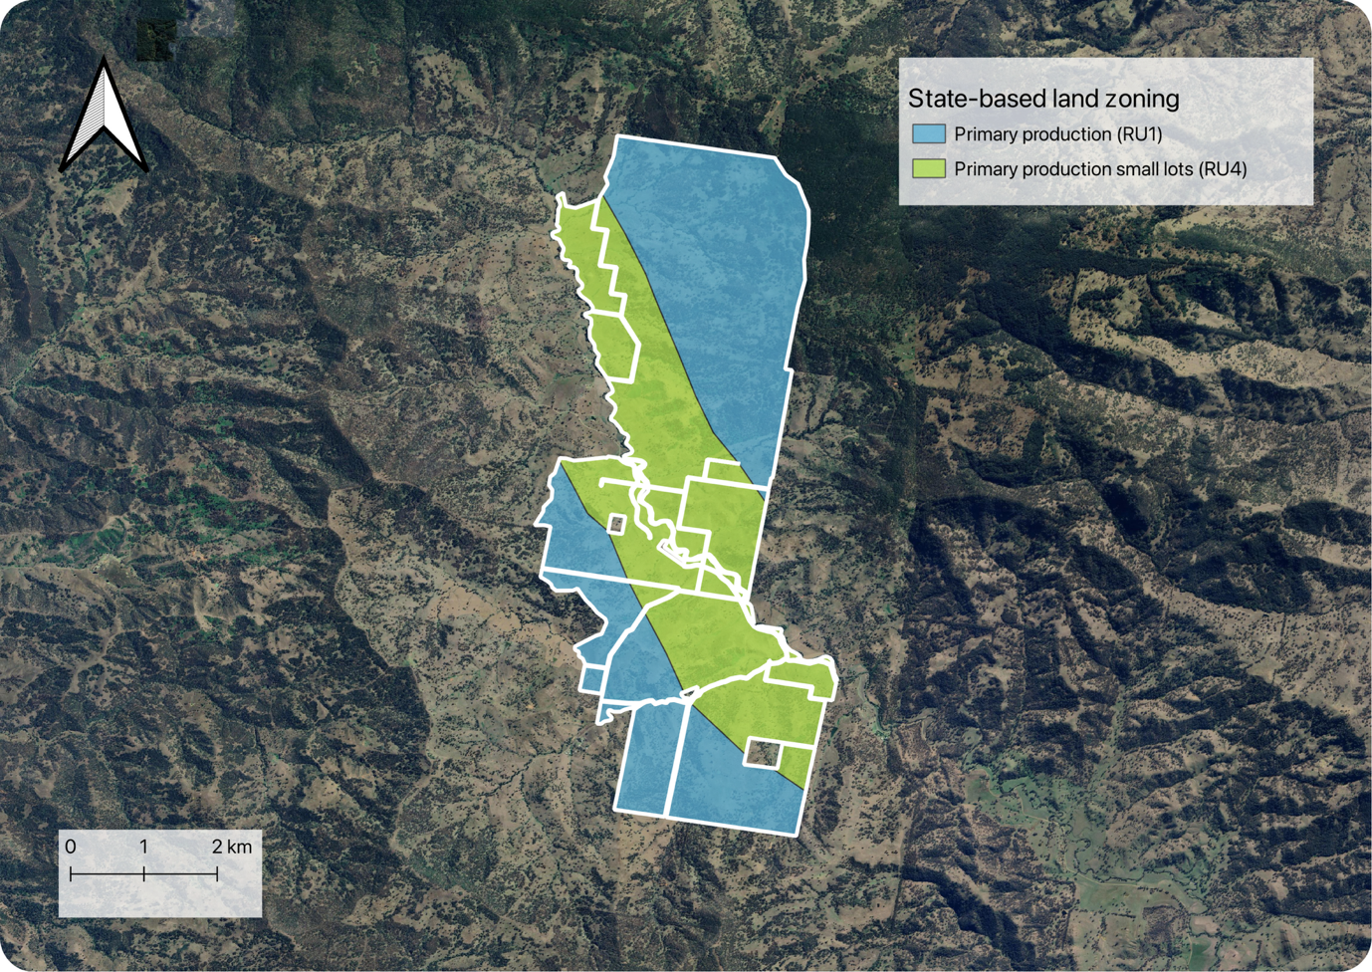

*Figure 9. State-based zoning of the Pages Creek property.*

## Land Titles

It is essential to evaluate whether a proposed project area is subject to land titles or other land uses that could potentially conflict with the development of a carbon project. While these alternative uses may not always prevent project implementation, they serve as indicators of potential risk, can influence the project timeline, and help identify key stakeholders who may need to be consulted during the planning process.

### Native title

Native title is a crucial assessment criterion for carbon projects as it identifies land tenure rights, Indigenous stakeholder engagement, and consent requirements, ensuring projects comply with legal frameworks and respect Traditional Owner interests.

There are no Indigenous Land Use Agreements or Native Title Determinations in or around the Pages Creek property (Figure 10). However, it is recommended that early engagement with local Indigenous communities be undertaken to begin the process of obtaining free, prior, and informed consent.

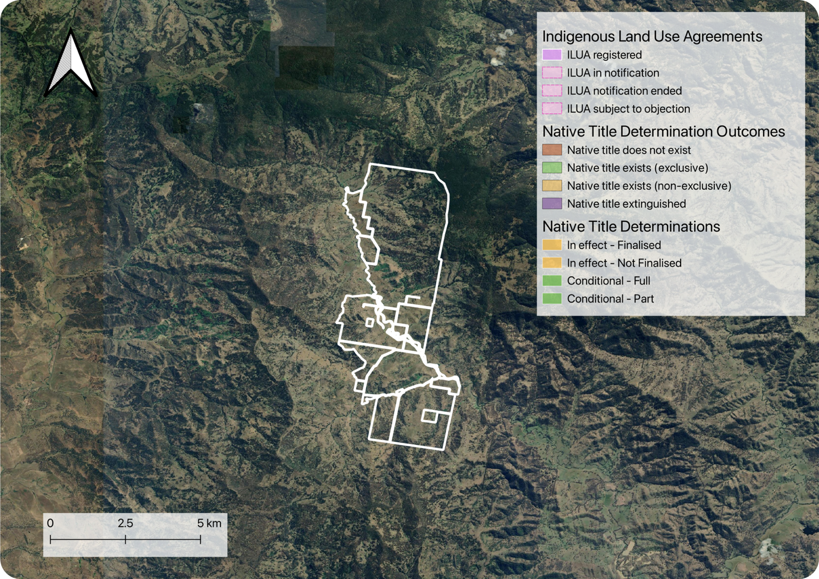

*Figure 10. Mapping of Indigenous Land Use Agreements in and native title determinations in and around the Pages Creek property.*

### Mining tenements and exploration licences

Understanding mining tenements and exploration licenses help ensure project security, regulatory compliance and alignment with long-term land management objectives. There are currently no mining tenements or exploration licenses that intersect with the Pages Creek property (Figure 11).

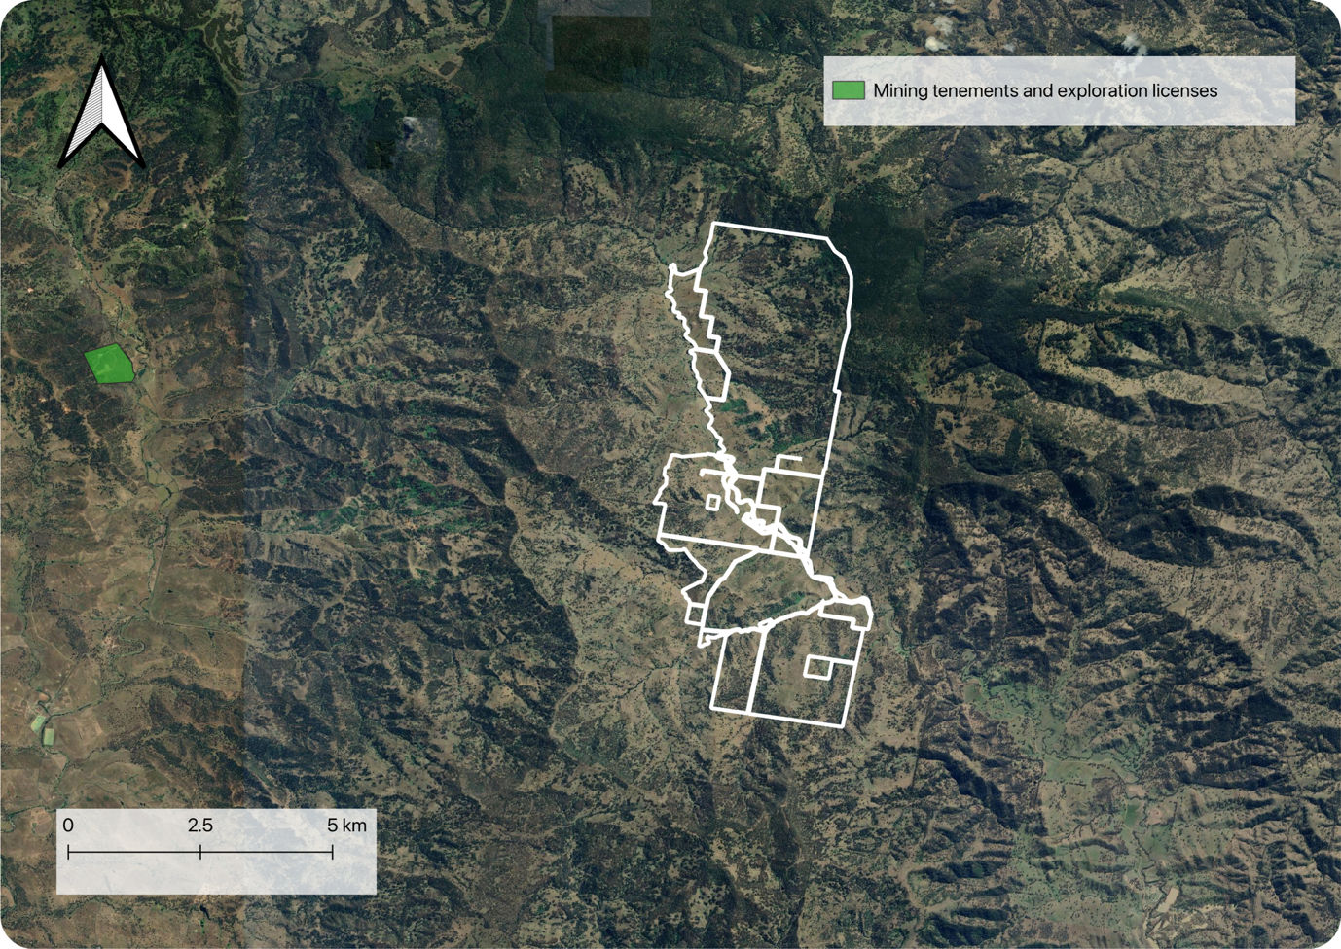

*Figure 11. Mining tenements and exploration licenses in and around the Pages Creek property.*

### Existing CER projects

If an area is already covered by an existing CER project, there is a risk of double counting carbon credits which can lead to non-compliance with carbon standards and making credits invalid or reducing their market value. Similarly, if an existing CER project is already addressing the same emission reductions, the new project might fail additionality tests and be ineligible for credits.

Currently, there is one CER-registered project within the entire property (ERF 194756 – Reforestation by Environmental or Mallee Planting, 2014). The CER-registered project identified immediately to the east is part of the same project, while an additional, separate CER-registered project is located to the north (see Figure 12).

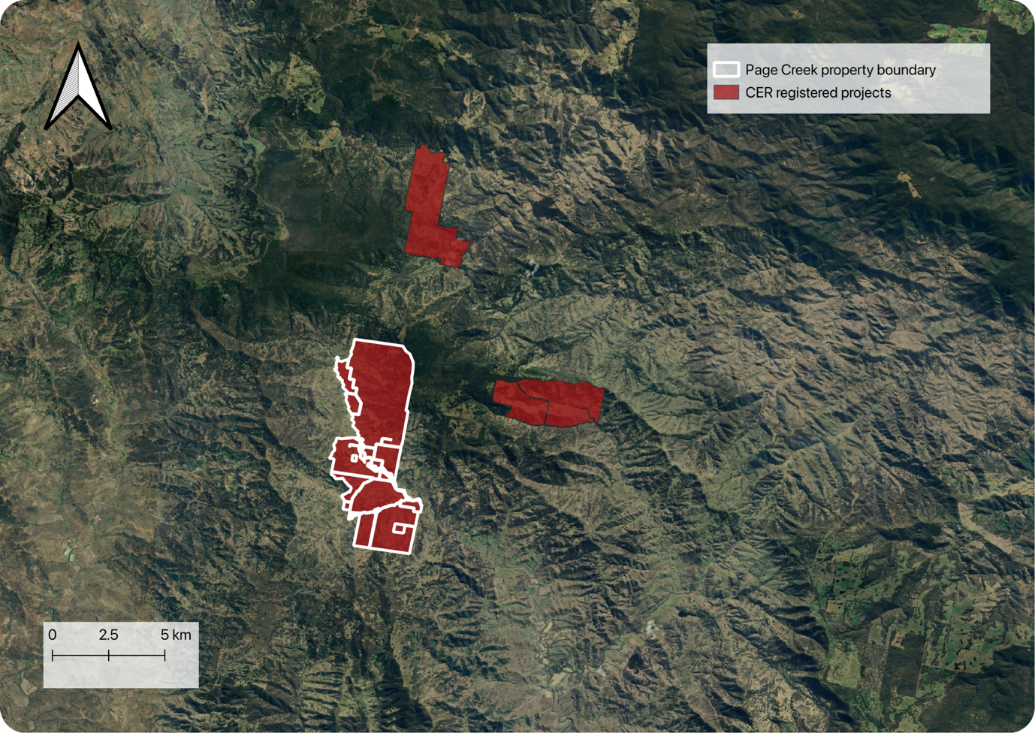

*Figure 12. Existing Clean Energy Regulator carbon projects in and around the Pages Creek property.*

# Environmental

Carbon projects, particularly those involving environmental plantings, face various environmental risks that can affect their success, long-term viability, and ability to generate Australian Carbon Credit Units (ACCUs). These risks must be carefully assessed and managed to ensure project permanence and compliance with Emissions Reduction Fund (ERF) requirements.

## Climate

Climate and weather-related risks (e.g. rainfall and temperature), play a significant role in determining the success and long-term viability of carbon projects, and can inform when certain project activities such as weed management or tree planting should take place

### Precipitation

The Pages Creek property is located in a temperate region with no dry season and warm summers.

Precipitation is highest during summer, specifically in December, averaging approximately 95 mm. Rainfall then sharply decreasing through autumn reaching its lowest point in April, with an average of about 40 mm.

Based on historical precipitation data, the Pages Creek property presents a low risk for project development. The optimal window for conducting tree planting operations is during the late Winter-to-Spring and early Summer period, when conditions are most favourable.

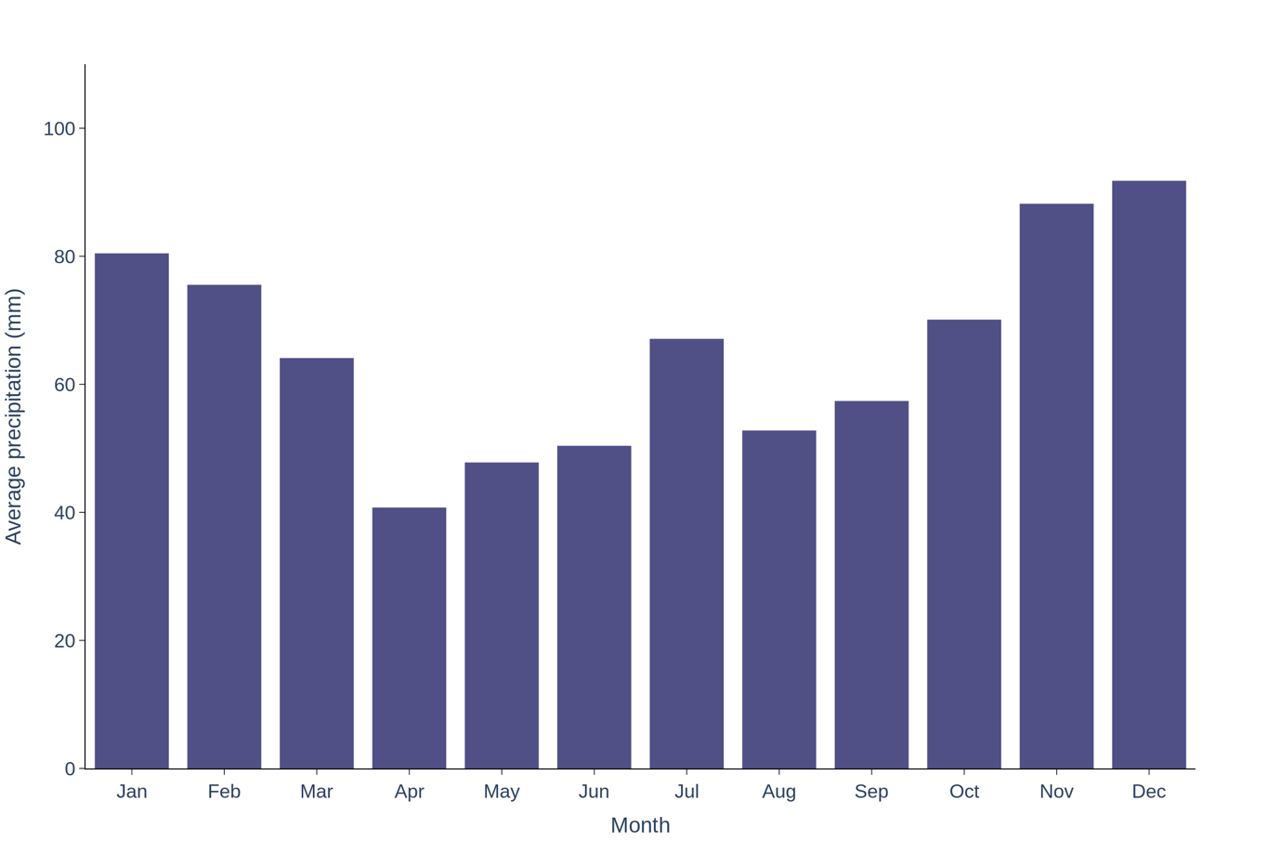

*Figure 13. Interpolated climate data from the Bureau of Meteorology and other providers at a 5km resolution. Average monthly precipitation (mm) over the year of the area surrounding the property using data from 1956 – 2024.*

### Temperature

In the summer months, spanning December, January, and February, the mean maximum temperature averages around 26.4°C, while the mean minimum temperature is approximately 13.4°C. During the winter months of June, July, and August, the mean maximum temperature drops to about 13.1°C, and the mean minimum temperature averages approximately 2.3°C (Figure 14).

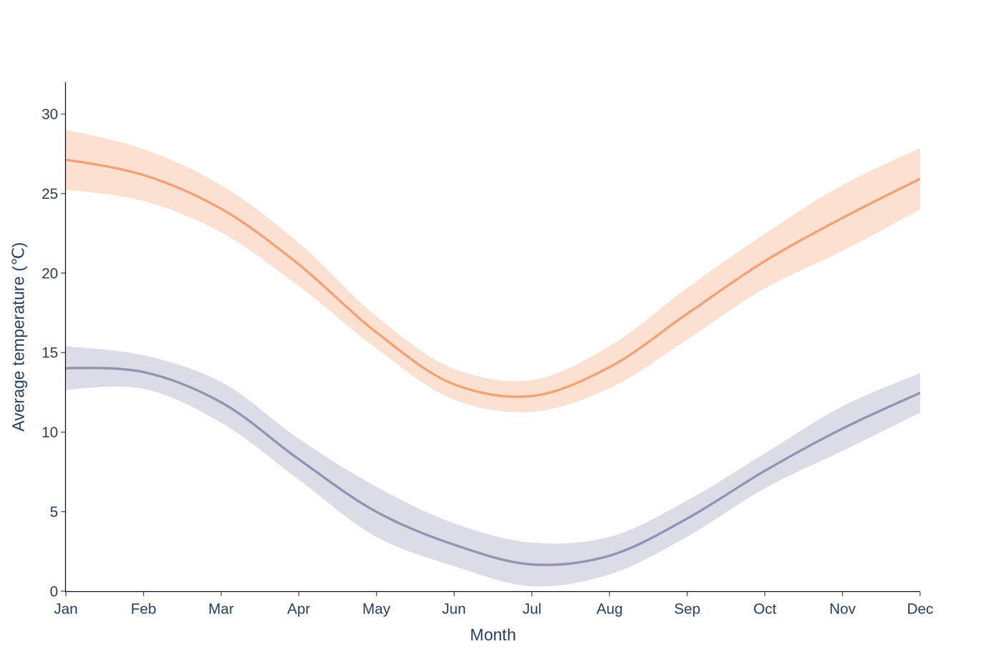

*Figure 14. Interpolated climate data from the Bureau of Meteorology and other providers at a 5km resolution. The figure shows the mean minimum and mean maximum monthly temperatures from data between 1956 to 2024.*

### Frost

Days below zero degrees Celsius (indexed by frost days) present as a risk towards the establishment and survival of young plants. Long term data indicates that frost does not occur in and around the property of Pages Creek (Figure 15).

Frost is expected during late winter to early spring. In June and July, frost days are frequent, with an estimated 25 days experiencing days below zero degrees Celsius.

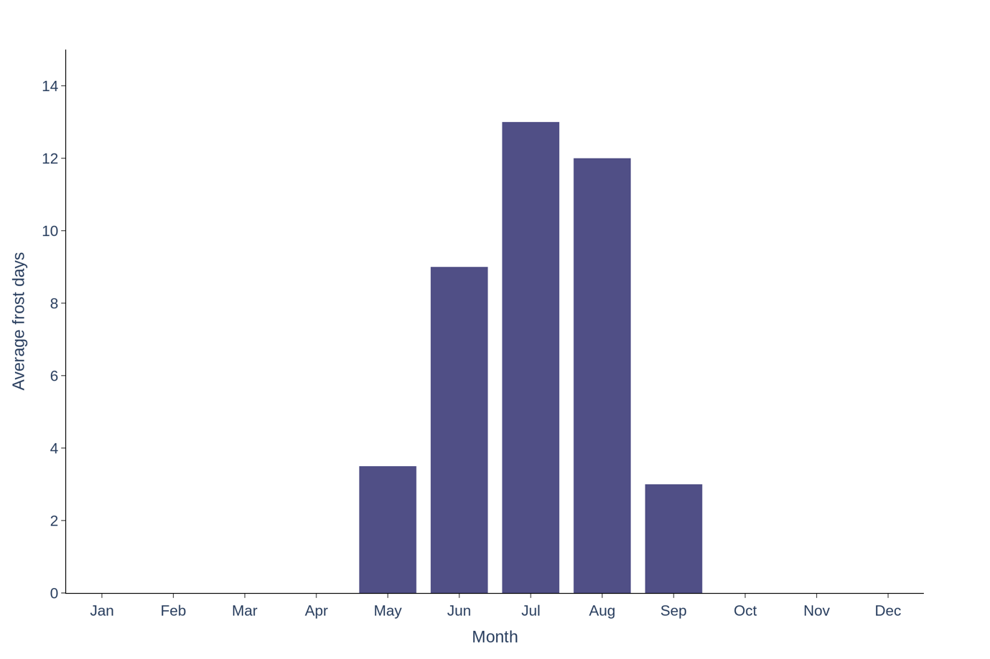

*Figure 15. Median number of days with temperatures below 0°C since 1956.*

## Drought risk

Drought and reduced rainfall can significantly impact carbon projects. For example, by degrading soil, increasing mortality of seedlings, slowing down tree growth - in turn all impacting sequestration rates, requiring replanting and increasing costs.

Drought risk around the Pages Creek property is ‘high’. In the past 20 years, there have been more severe-to-extreme dry periods when compared to very-to-extreme wet periods (Figure 16).

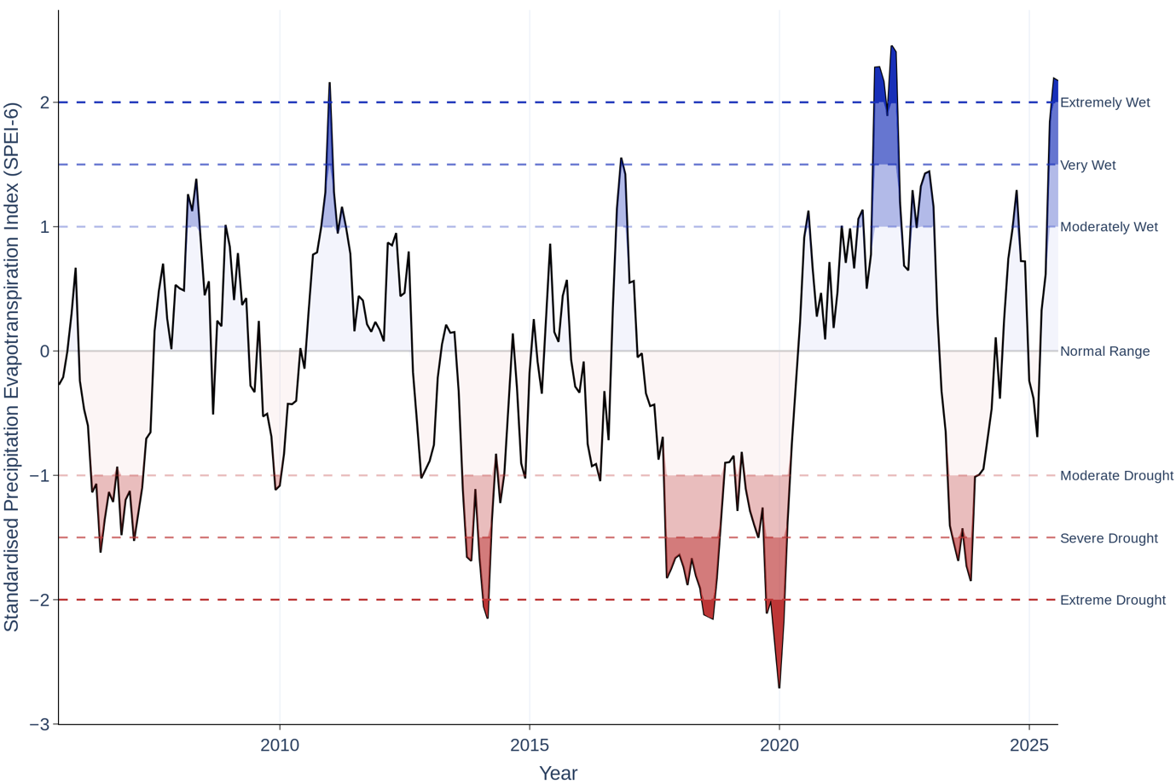

*Figure 16.* *The Standardised Precipitation Evapotranspiration Index data for the past 20 years, grouped by 6 months, of the region surrounding the Pages Creek property.*

## Bushfire risk

The region surrounding the property has experienced a considerable number of fire events. Three prescribed burns were recorded in October 2012, September 2012, and March 2019. In contrast, wildfires have been significantly more frequent, with at least 17 incidents documented between October 2000 and December 2019. In 2019, fire also directly affected the northern extent of the property (Figure 17). The overall bushfire risk for the Pages Creek property is classified as moderate due to the large proportion of fire-prone land within the property and its location in a region with a high frequency of fire.

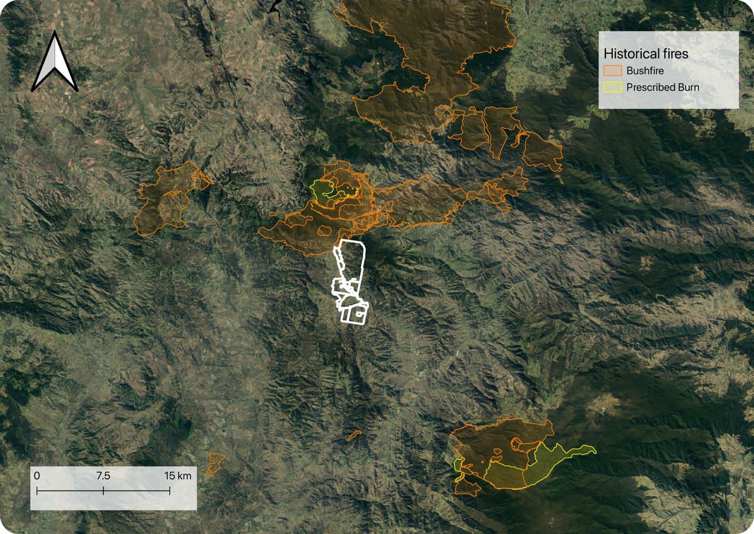

*Figure 17. The bushfire history (prescribed burn and wildfire) in the region surrounding the Pages Creek property. The property boundaries are identified by the white bordered polygons.*

## Flood risk

Flooding and heavy rainfall events can have significant negative impacts on carbon projects. These events may lead to soil erosion and loss, damage to seedlings and plant root systems, and in severe cases, plant mortality. Such outcomes can delay carbon sequestration timelines and increase project costs due to the need for replanting and site rehabilitation.

According to the National Flood Risk Model (FRM) - which uses a statistical-morphological approach to estimate inundation probability - the Pages Creek property is assessed as having a very low risk of flooding (Figure 18).

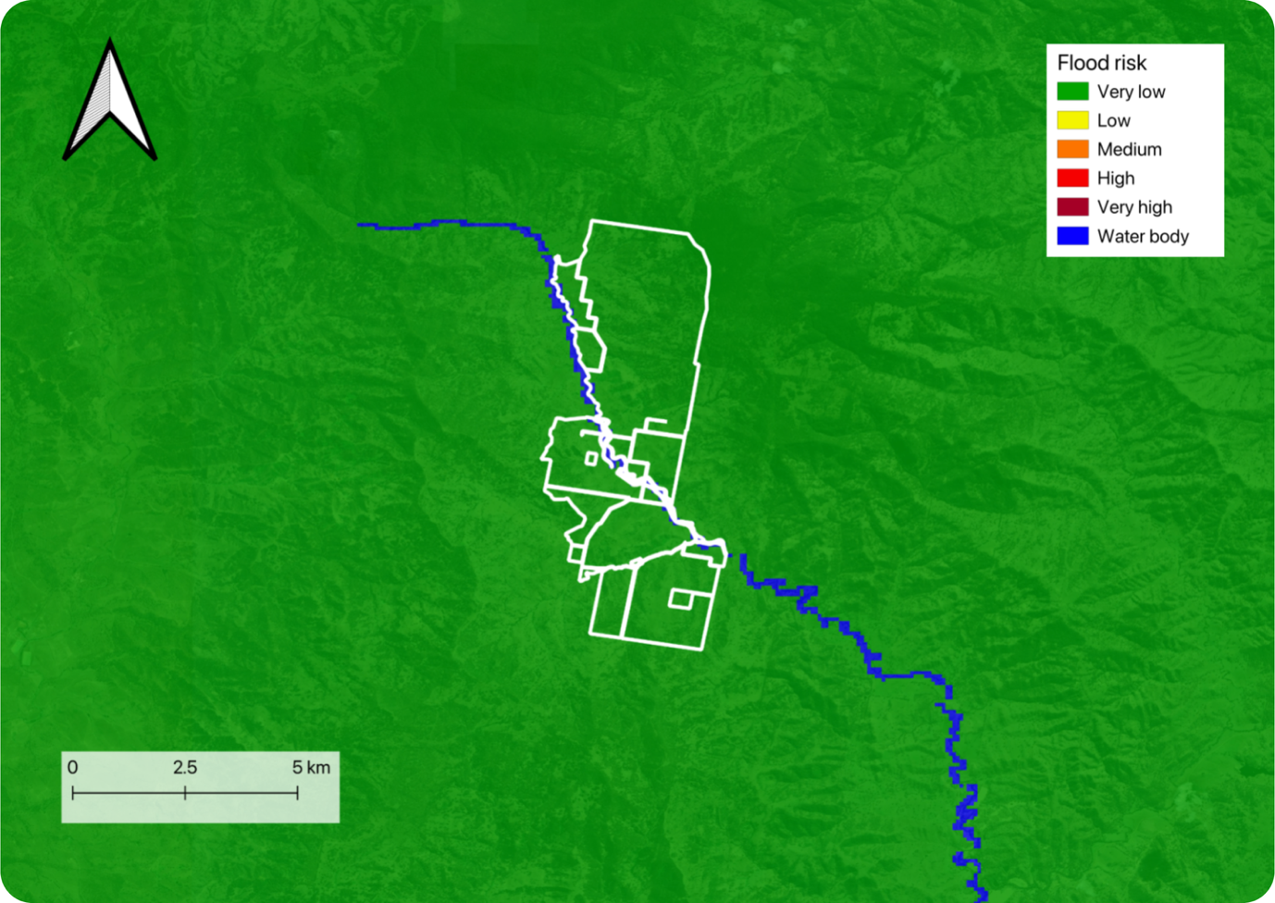

*Figure 18. The probability of inundation for the region surrounding the Pages Creek property, based on a National Flood Risk Model.*

## Salinity

Salinity, or the concentration of salt in soil and water, can significantly influence the success and carbon sequestration potential of environmental projects, where high salinity can be a major constraint on plant growth and soil health, making it a critical factor to consider in carbon project design and management.

### Dryland salinity

Dryland salinity refers to the accumulation of salts in the soil of non-coastal (dryland) areas, which primarily affects agricultural lands, natural ecosystems, and water quality. It occurs in areas with low rainfall and can result from both natural processes and human activities, often exacerbated by land use changes such as agriculture and deforestation.

The Pages Creek property does not overlap with any areas currently mapped as having a high risk of dryland salinity and presents as very low risk (Figure 19).

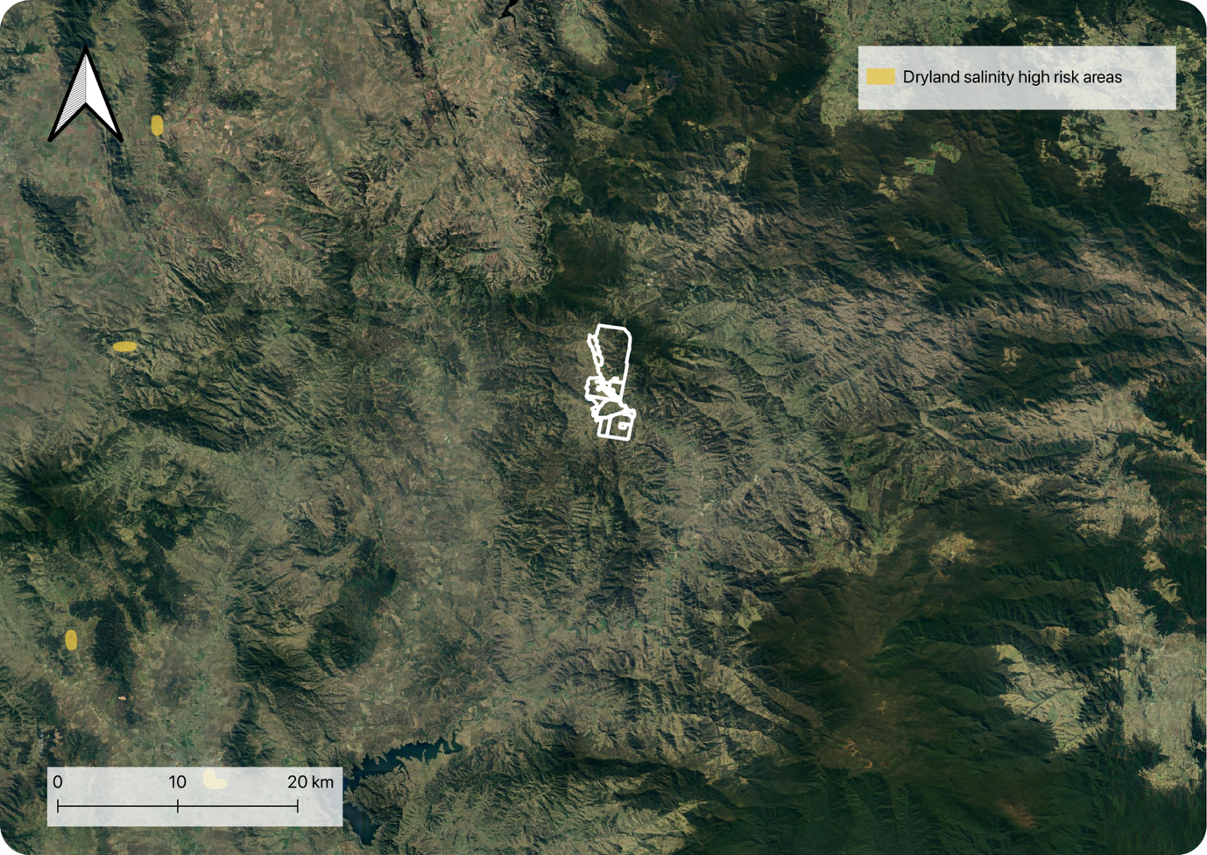

*Figure 19.* *High risk areas of dryland salinity in the region surrounding the Pages Creek property*

# Biogeography

In the context of carbon projects, biogeography plays a crucial role in determining suitable and eligible locations, vegetation types, and carbon sequestration potential for environmental plantings.

## Vegetation

### Major Vegetation Groups (pre-European settlement)

Australia's vegetation is classified into Major Vegetation Groups (MVGs) at a national scale based on dominant plant communities, climate, and ecological characteristics (pre-European settlement). Assessing MVGs across a potential project area is critical in determining whether the proposed planting area can achieve forest cover[2], and is suitable and eligible for project implementation.

Based on MVG mapping, the entirety of the planting area of the Pages Creek property can achieve forest cover and the property presents as a very low risk for project development.

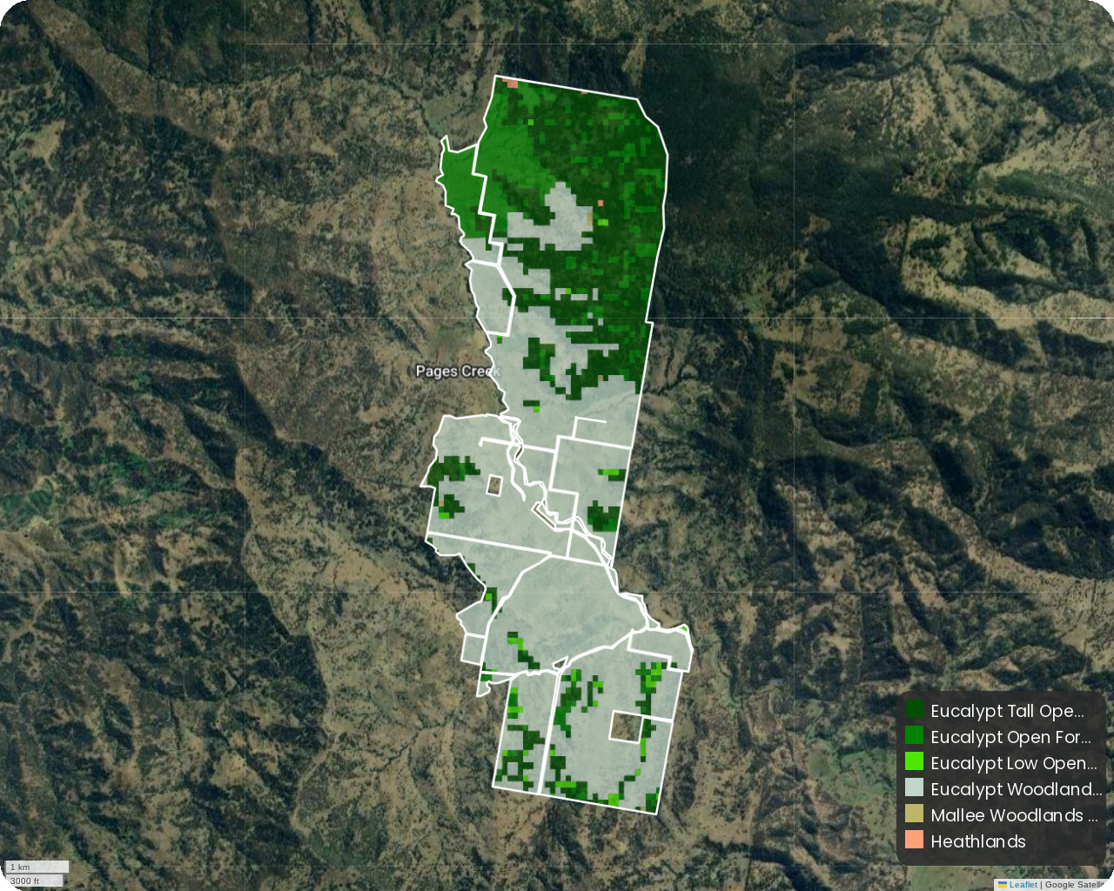

*Figure 20. Mapped Major Vegetation Groups (MVG) within the Pages Creek property*

### Fine-scale state-based vegetation mapping (pre-European settlement)

State-based pre-European vegetation (PEV) mapping offers more granular insights into the natural ecosystems that existed before significant human intervention. PEVs help to further assess whether the proposed planting area can achieve forest cover but is also key for defining an initial benchmark for restoration goals, guide species selection, optimising planting strategies, inform potential project co-benefits such as restoring threatened ecological communities and/or critical habitat for threatened species. By restoring PEV, projects increase their likelihood of qualifying for higher quality carbon credits while simultaneously delivering local benefits to native flora and fauna, thereby improving landscape-scale system resilience.

In accordance with state-based ‘Pre-European Vegetation’ mapping, there are 16 plant community types (PCTs) on the Pages Creek property. The dominant PCTs, based on their proportion of the planting area, are Liverpool Range Box-Silvertop Stringybark Forest (42.95%), Northwest White Box Woodland (27.43%), Liverpool Range Montane Stringybark Forest (16.31%). State-based vegetation mapping supports the MVG classification, indicating that Pages Creek poses a very low risk for project development, as all eligible planting areas are capable of achieving forest cover.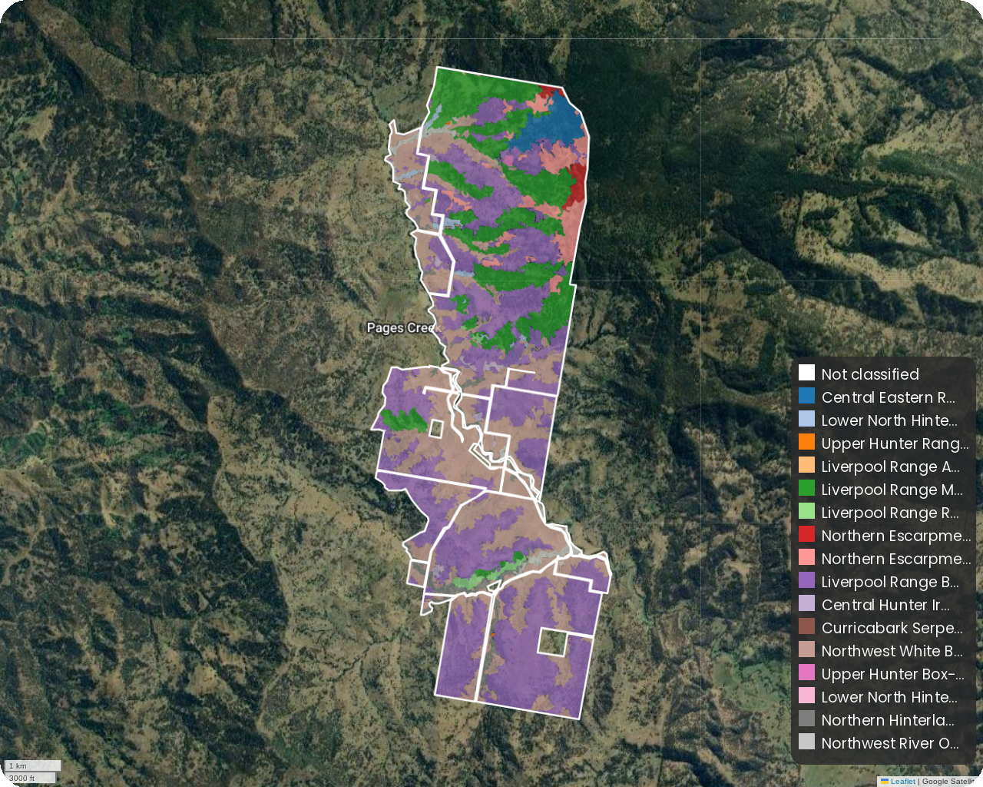

*Figure 21. State-based Pre-European vegetation within the Pages Creek property.*

## Soil

Soil is fundamental to the success of any restoration project, directly impacting plant establishment and long-term survival. Understanding soil characteristics helps identify risks early and informs key actions such as targeted soil testing, land remediation, and site preparation. A well-informed soil assessment ensures a strong foundation for restoration success.

The property's soil profile is dominated by Dermosols, covering approximately 95.38% of the area, followed by smaller proportions of Ferrosols (2.26%), Chromosols (1.31%), and Tenosols (1.05%). Dermosols have structured B2 horizons with minimal texture contrast. Chromosols feature a strong texture contrast and are generally favourable for agriculture, although some may have subplastic B horizons requiring attention. Ferrosols, rich in iron oxides and known for favorable physical characteristics, are widely regarded as suitable for environmental plantings. Tenosols, in contrast, are weakly developed, often shallow, and may overlay hardpans or rock, which restricts root penetration and water retention. These properties make Tenosols the least favorable for tree establishment without significant management interventions.

Overall, higher-risk soils comprise only a small portion of the property, indicating that Pages Creek poses a very low risk for project development. Nevertheless, it is advisable to conduct a site inspection to assess the impact of historical and current land management practices on soil condition. Gaining insight into any changes in soil structure or function will be essential for identifying potential risks that could affect the success of project implementation.

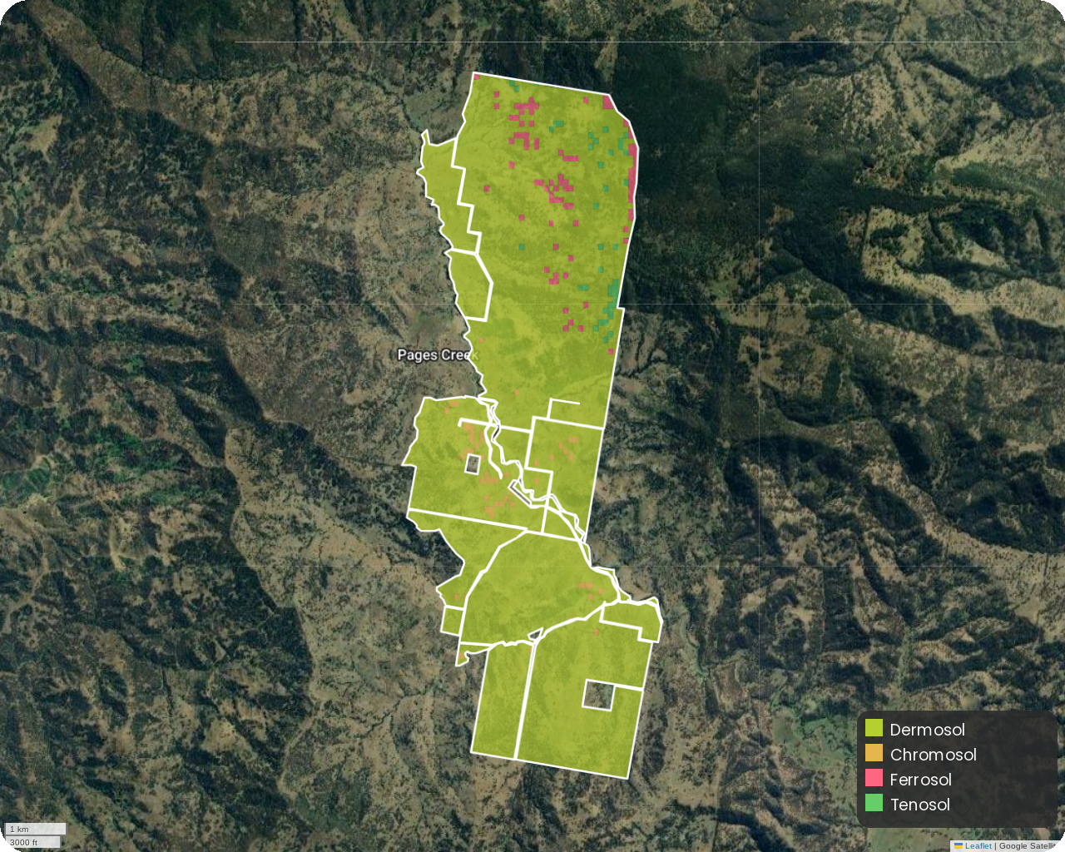

*Figure 22. Australian Soil Classification mapping within the Pages Creek property.*

# Next steps

## Summary

Overall, Pages Creek property presents as a low yielding carbon EP project with some key risks that may threaten the project viability over time. Based on this comprehensive, property-specific assessment of factors relevant to the feasibility of an Environmental Planting (EP) carbon project on your land, it is highly recommended that a site visit is conducted to ground truth these initial desktop observations.

### The Carbon Project Journey: From Assessment to Management

The development of a carbon project follows several key stages summarised in Figure 23.

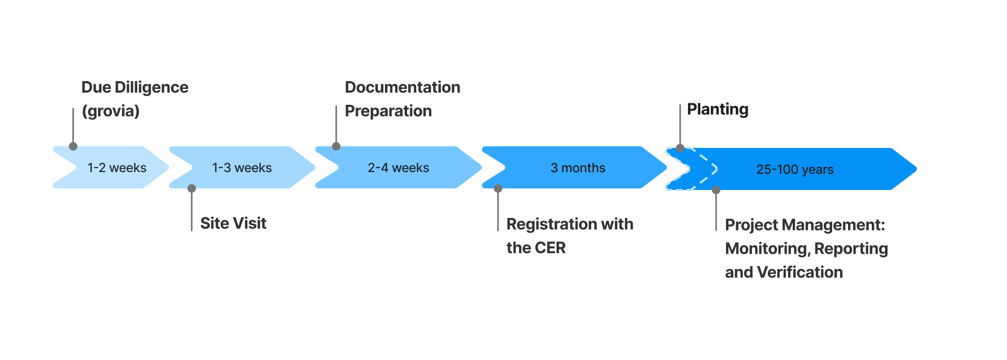

*Figure 23. A timeline outlining the key stages of a carbon project, from due diligence, site visit and document preparation, to CER project registration, establishment and ongoing monitoring, reporting, and verification post-planting.*

This desktop assessment is part of the ‘Due Diligence’ stage; a thorough and structured process of assessing a project before making a commitment to proceed. grovia supports this critical stage with additional tools such as Cost Calculator to understand your net position after costs and preparing for a site visit. Together, these features provide a strong foundation for confident, informed decision-making.

## Action Plan

If your property shows promise for an EP carbon project, you have three ways to move forward:

### 1. Understand What’s Involved to Be Registration Ready

Familiarise yourself with the key requirements and milestones needed to progress toward registration with the Clean Energy Regulator (CER). This includes preparing documentation such as a Reforestation Management Plan and Permanence Plan to support your application. Clarity at this stage sets a strong foundation for everything that follows.

→ Best for those wanting a clear understanding of what’s required to get registration-ready before taking the next step.

### 2. Prepare for Your Site Visit

Get ready for the critical site visit that validates your desktop assessment and moves your project from concept to ground-truthed reality. This step includes verifying mapped exclusion zones (e.g. deforested areas), identifying on-site constraints, and completing vegetation community (PCT) mapping to inform your species list.

Information gathered during the site visit will likely inform the recalculation of potential ACCUs by refining planting and exclusion areas; helping you better estimate the project’s carbon yield. A well-prepared visit enables accurate data capture and sets the stage for confident planning decisions.

→ Best for those ready to ground-truth their project and start getting practical about planting and implementation.

### 3. Plan Your Planting

Refine your restoration strategy by designing a site-specific planting plan. This includes determining line layout and spacing, selecting appropriate species, and choosing the most suitable planting method. Use the *Seeds Near Me* module to develop a species list tailored to local conditions and informed by seed availability. This step is essential for ensuring ecological integrity and meeting Clean Energy Regulator (CER) compliance requirements.

→ Best for those looking to prepare an optimal planting plan and move confidently toward implementation.

### Let’s Talk

Our team is available to support you with your next steps, whether that involves refining your proposed planting area after a site visit or moving forward with project registration.

We're here to help; reach out anytime and we'll work with you to find the best path forward.

Email: contact@grovia.earth



1. Areas designated for planting under the Reforestation by Environmental or Mallee planting method must not have had forest cover within the past 5 years. Furthermore, all CER carbon projects that involve establishing vegetation on land require that there must not have been clearing of any native forest within the 7 years of lodging the application (5 years if the land has changed ownership since the clearing). grovia’s initial assessment flags the likelihood that a property may encounter issues with eligibility if the project was to progress. grovia recommends that a site visit and further investigation is required to ground-truth these results.
2. Forest cover is defined as an area that can achieve at least 20% plant cover, derived from woody vegetation that is >2m in height.